Smartinterviews Day 1   
Working Notes and code document.

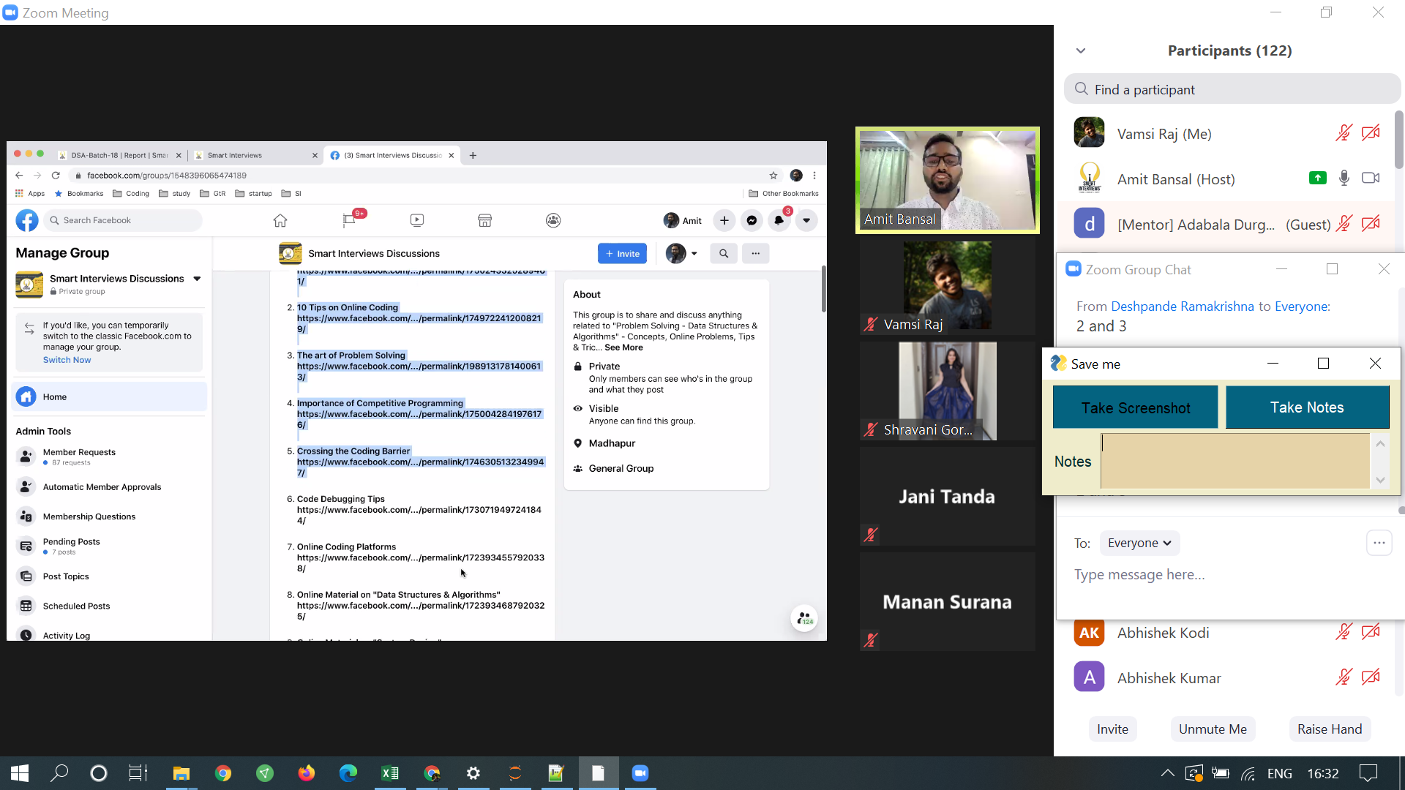

Slowly Finish reading the posts in facebook group.

If we come across problems when practicing or doing assignments.   
  
it should be in a certain format.   
  
Problem Link :   
Code Link: pastebin/codeshare/ideone..  
Verdict: WA/TLE/RTE/CE  
(WA- Wrong Answer/RTE - Runtime Error, CE- Compilation error.)

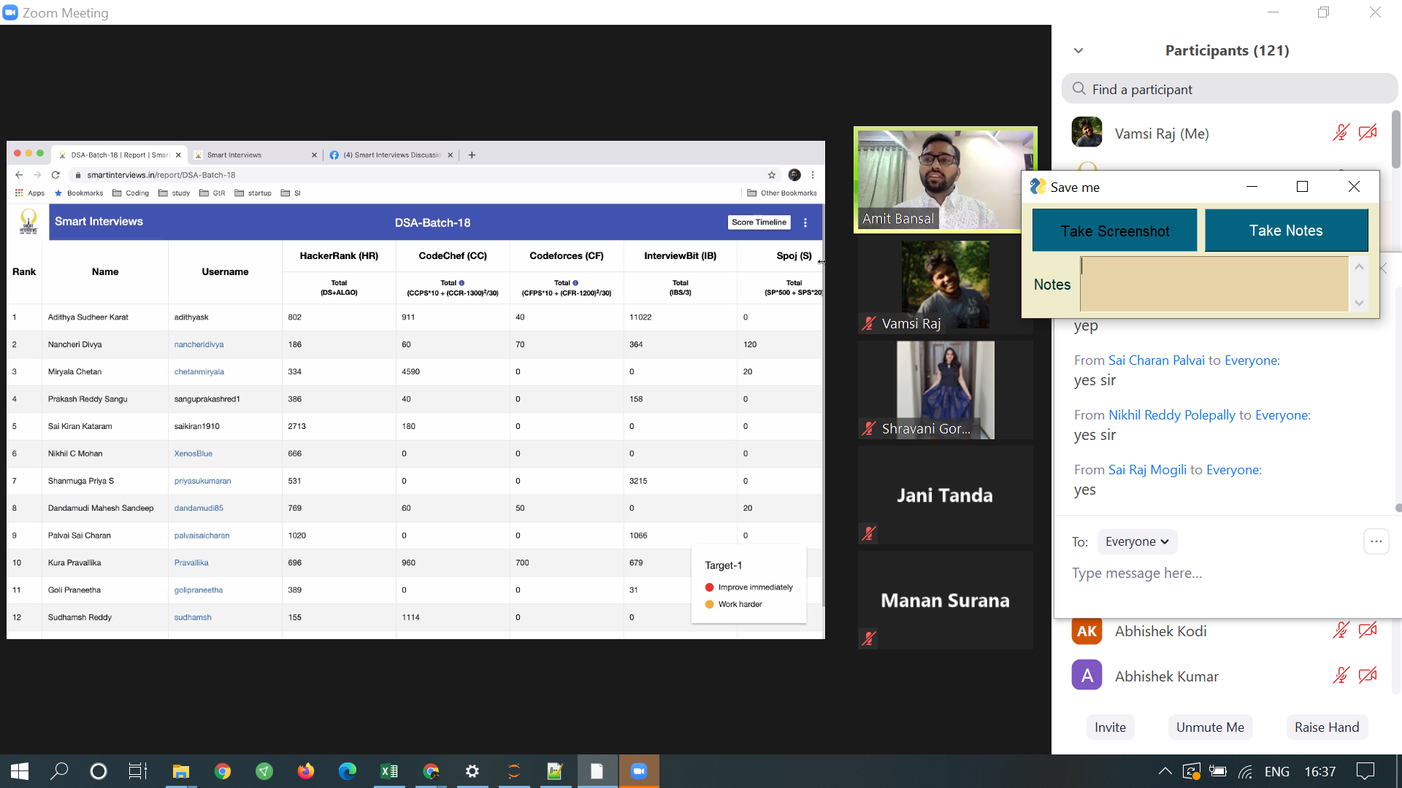

Thisi is a Batch Report.

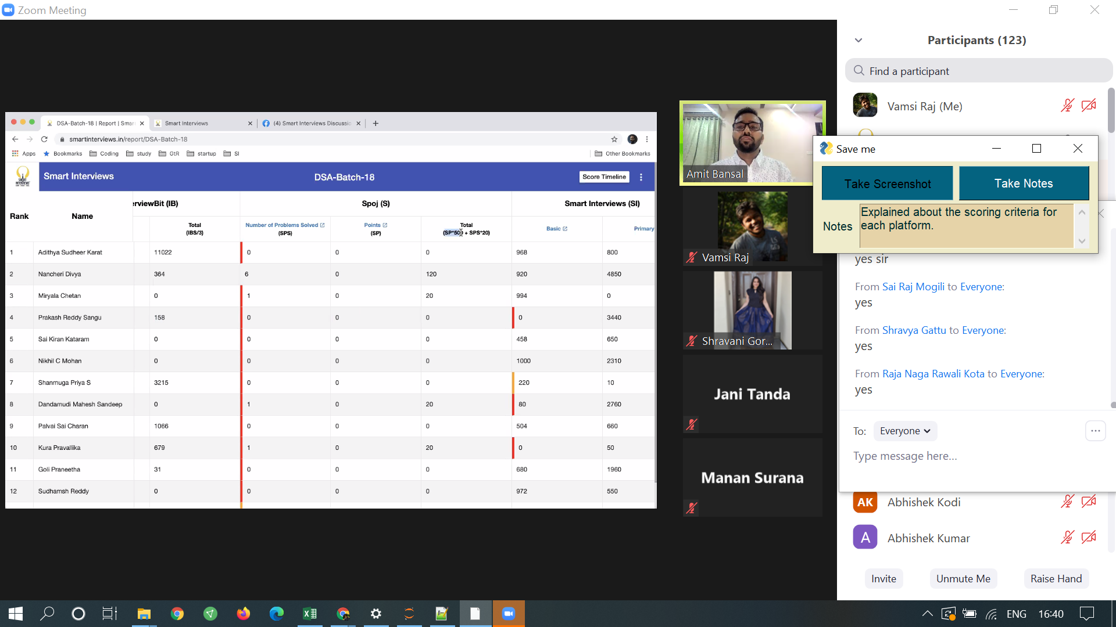

Explained about the scoring criteria for each platform.

The dashboard has - View Target.  
We should clear of the red and orange marking on our name.

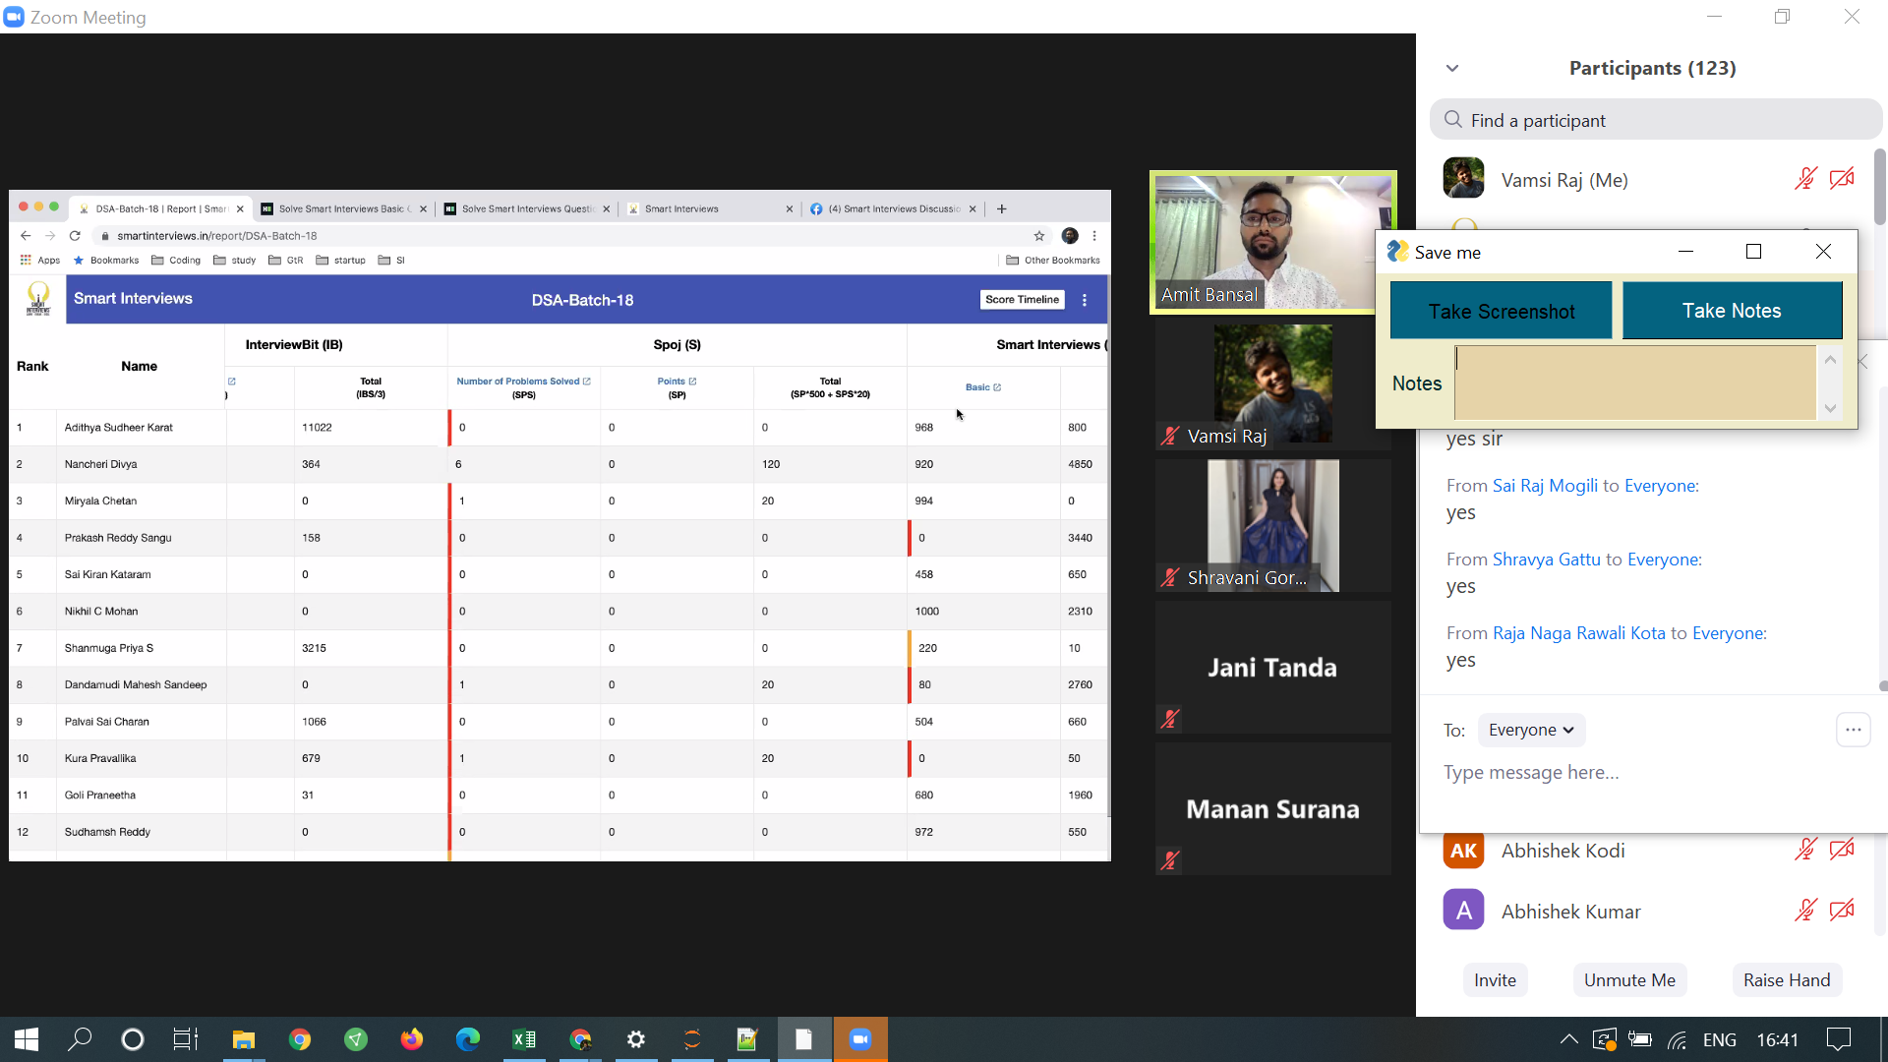

Need to open https://www.smartinterviews.in/report/DSA-Batch-18  
  
Need to open this link throughout the session. . Click on the 3 dots there and you can see option to mark activity. When asked we need to mark activity in that option.

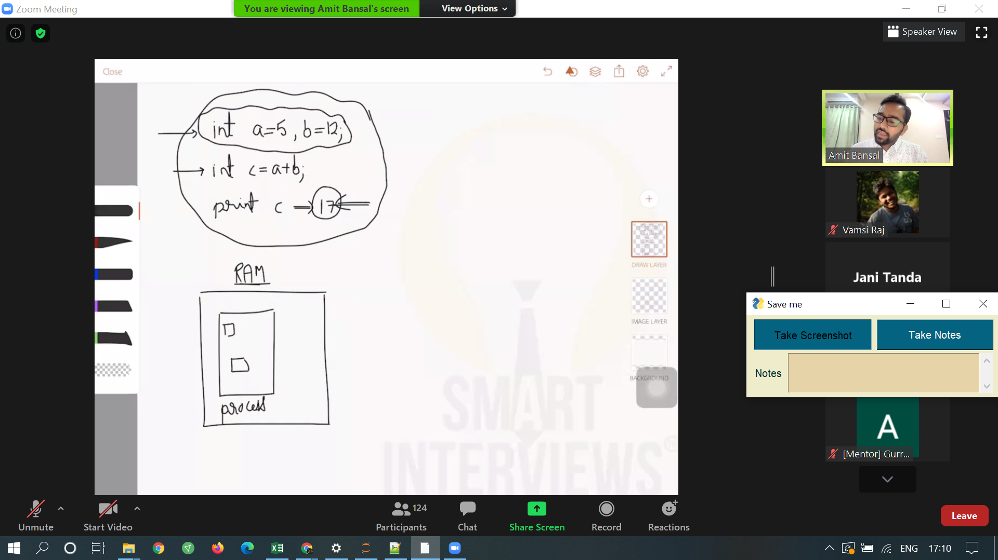

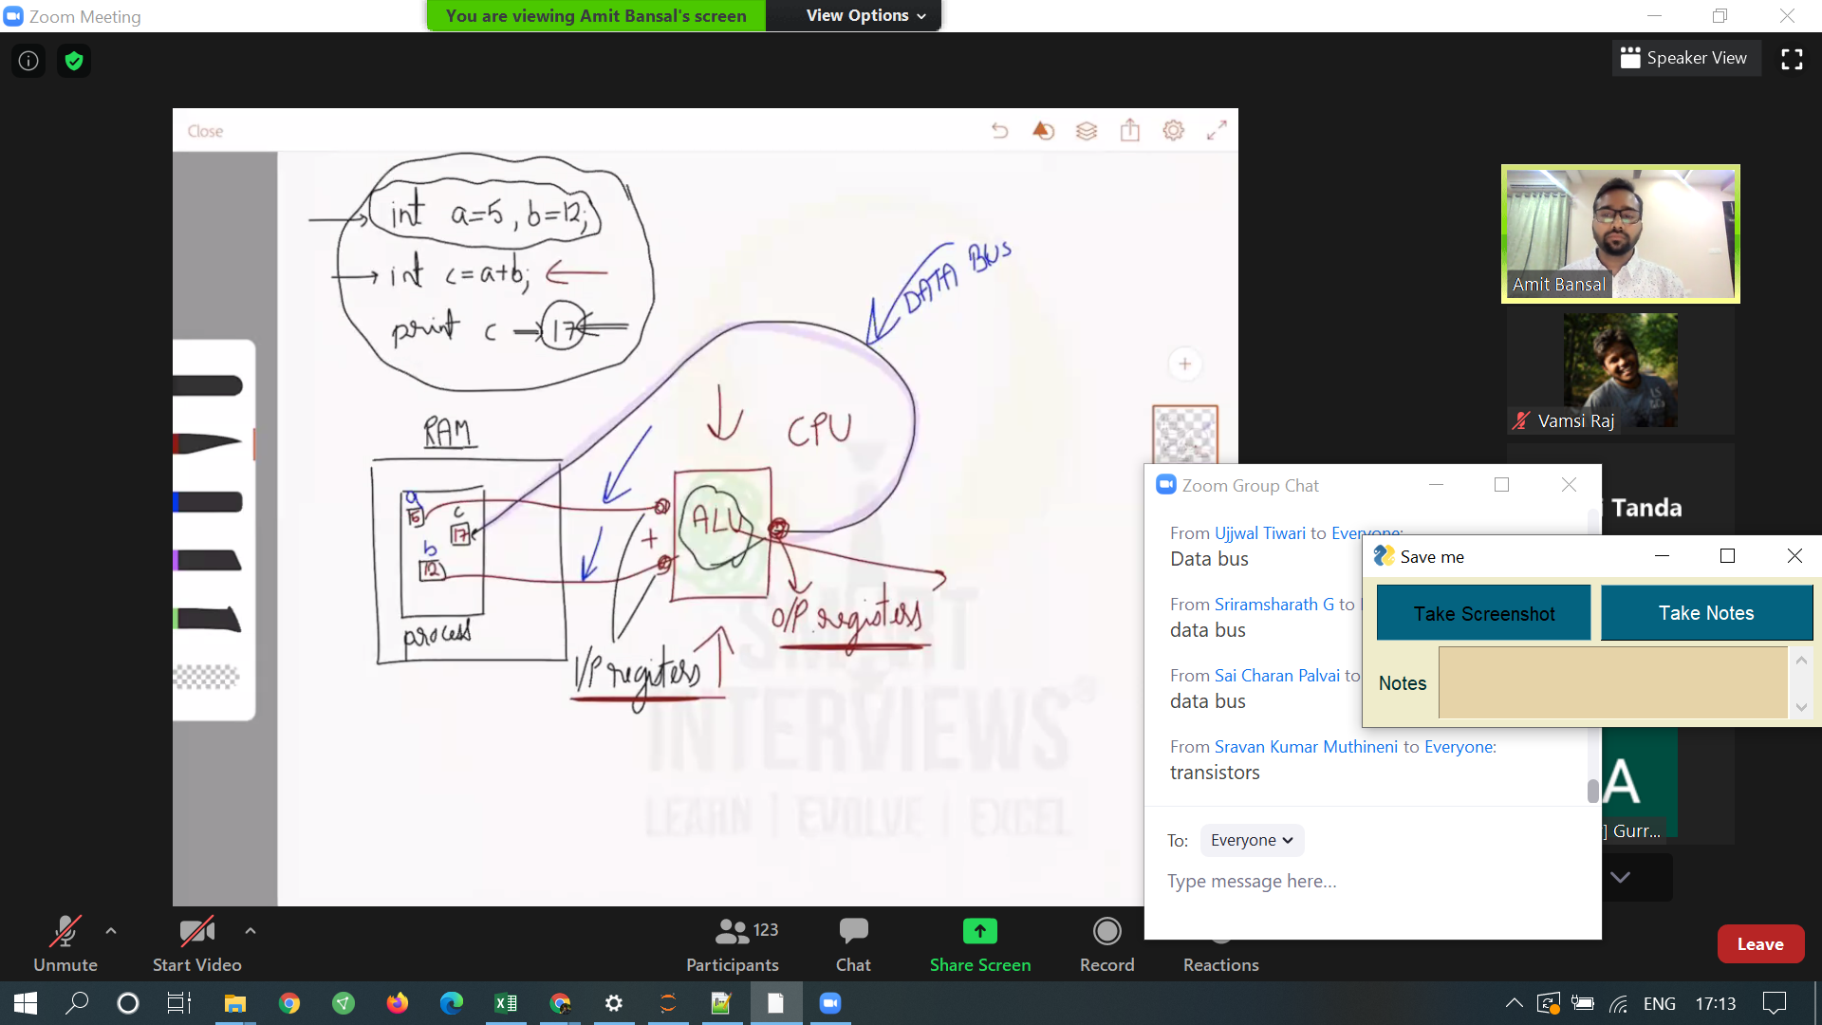

When we add 2 elements, there are lot of things that work in background. Databus,I/P and O/P Registers, ALU in CPU, and Gates.

#Read - About ALU

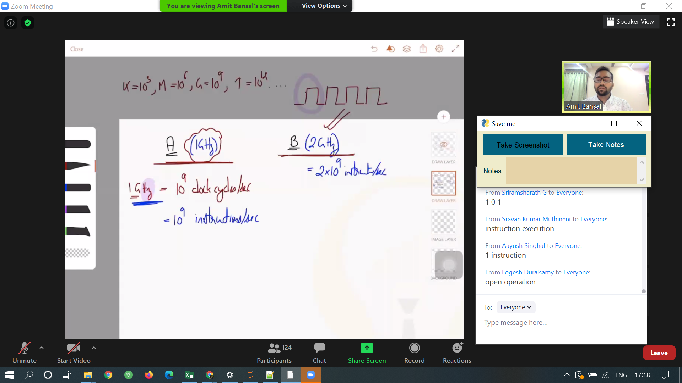

In comparing the processing power between 2 systems.   
We compare Clockspeed and Ram size.

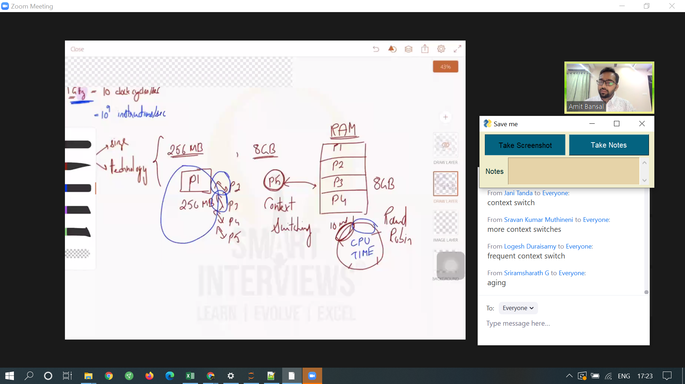

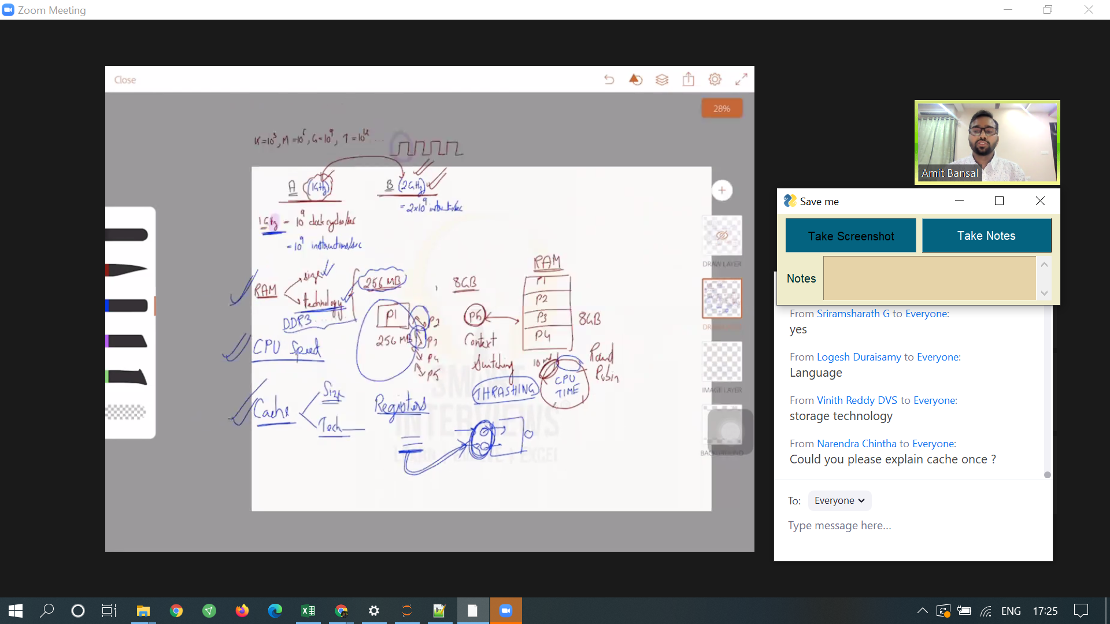

Ram, Cache, storage, clockspeed all affect performance.

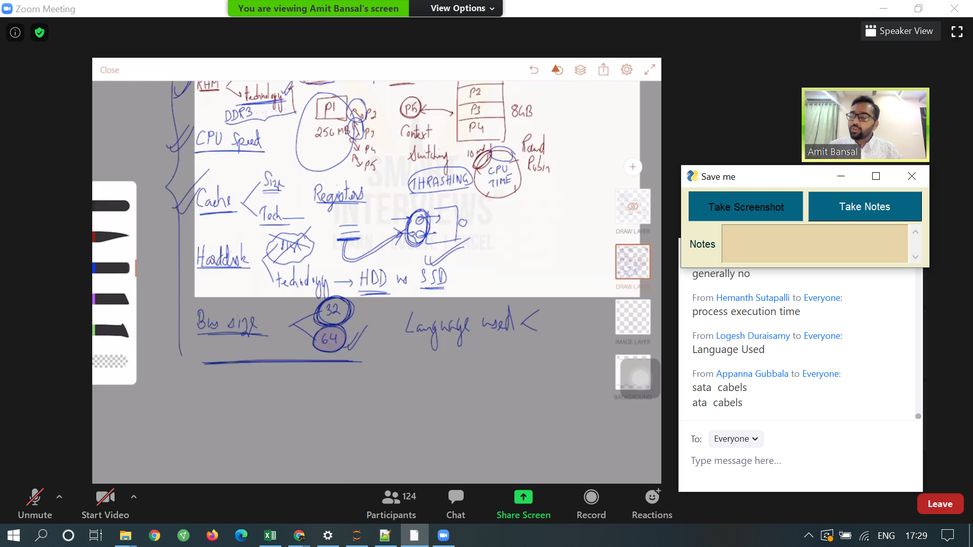

OS also affects the performance.   
v1,v2,v3 - bug fixes, optimizations, new features are added in each version.   
So Software also affects the performance of the system.

#TODO -   
1.Read about technologies of RAM.  
2.Read about types of hardware cache.

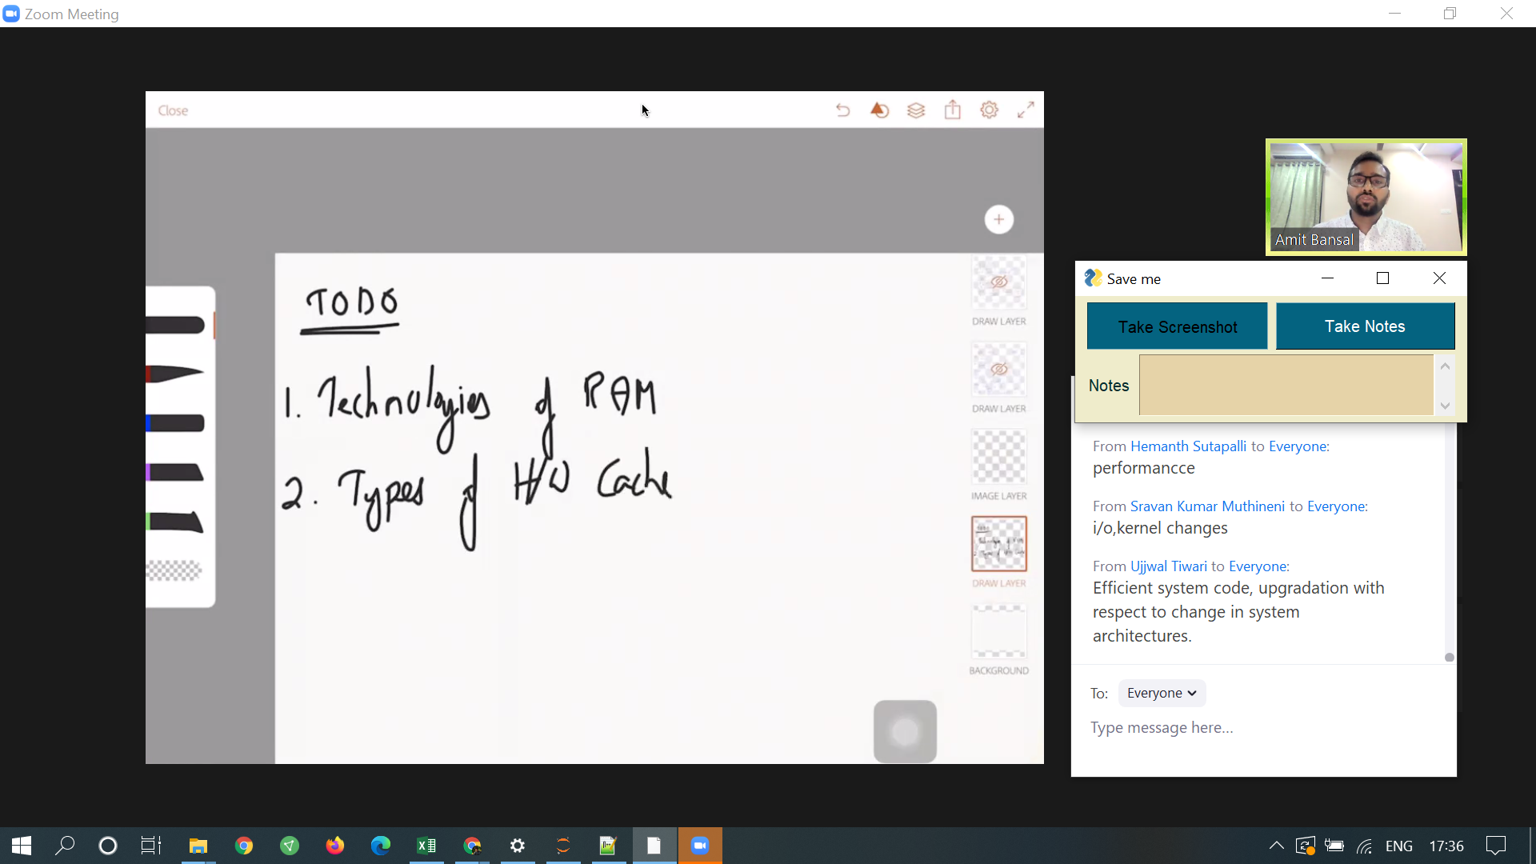

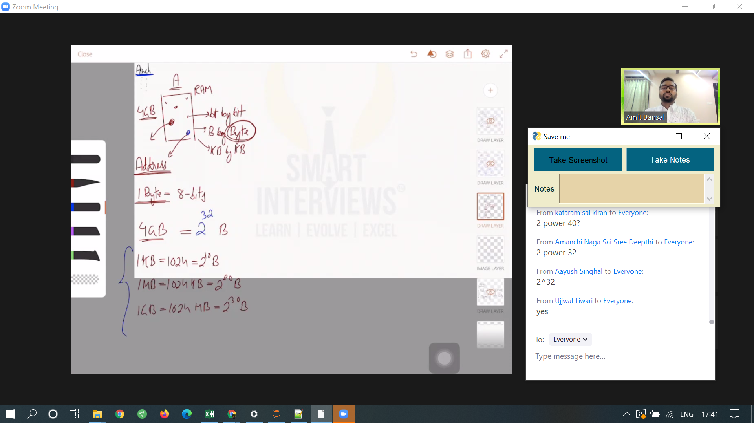

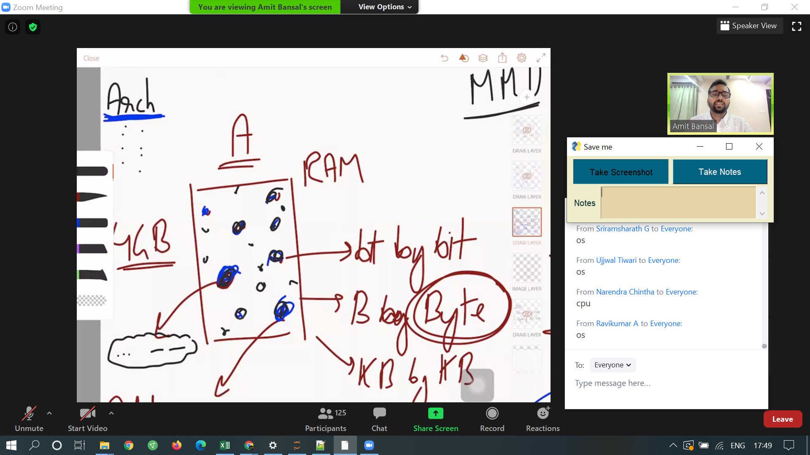

data address is maintained by MMU controlled by OS and carried by addressbus.

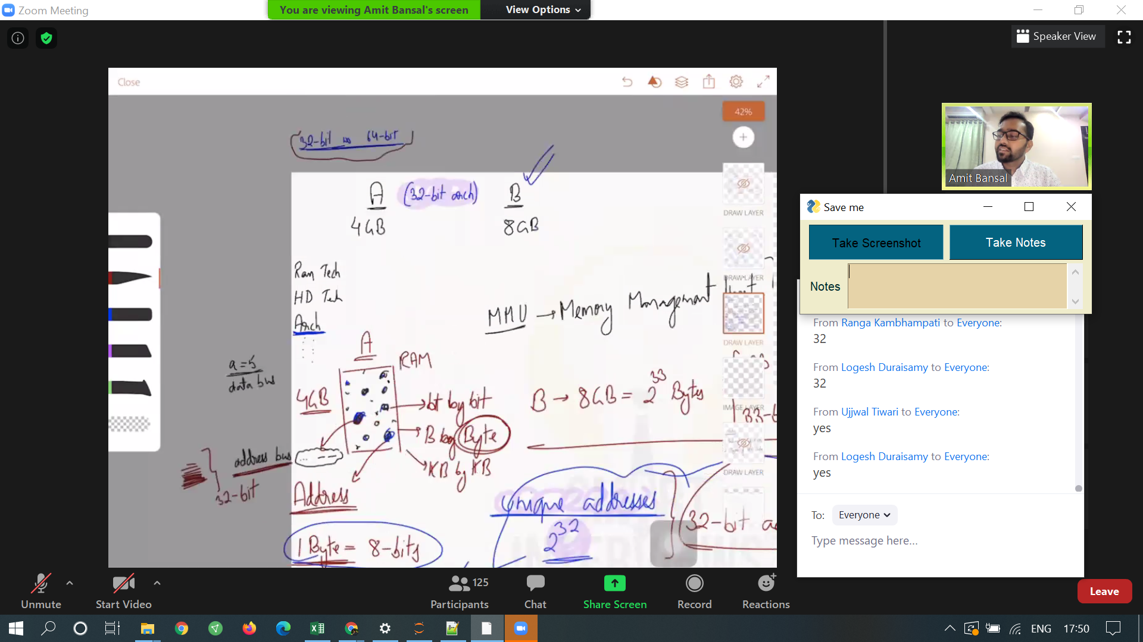

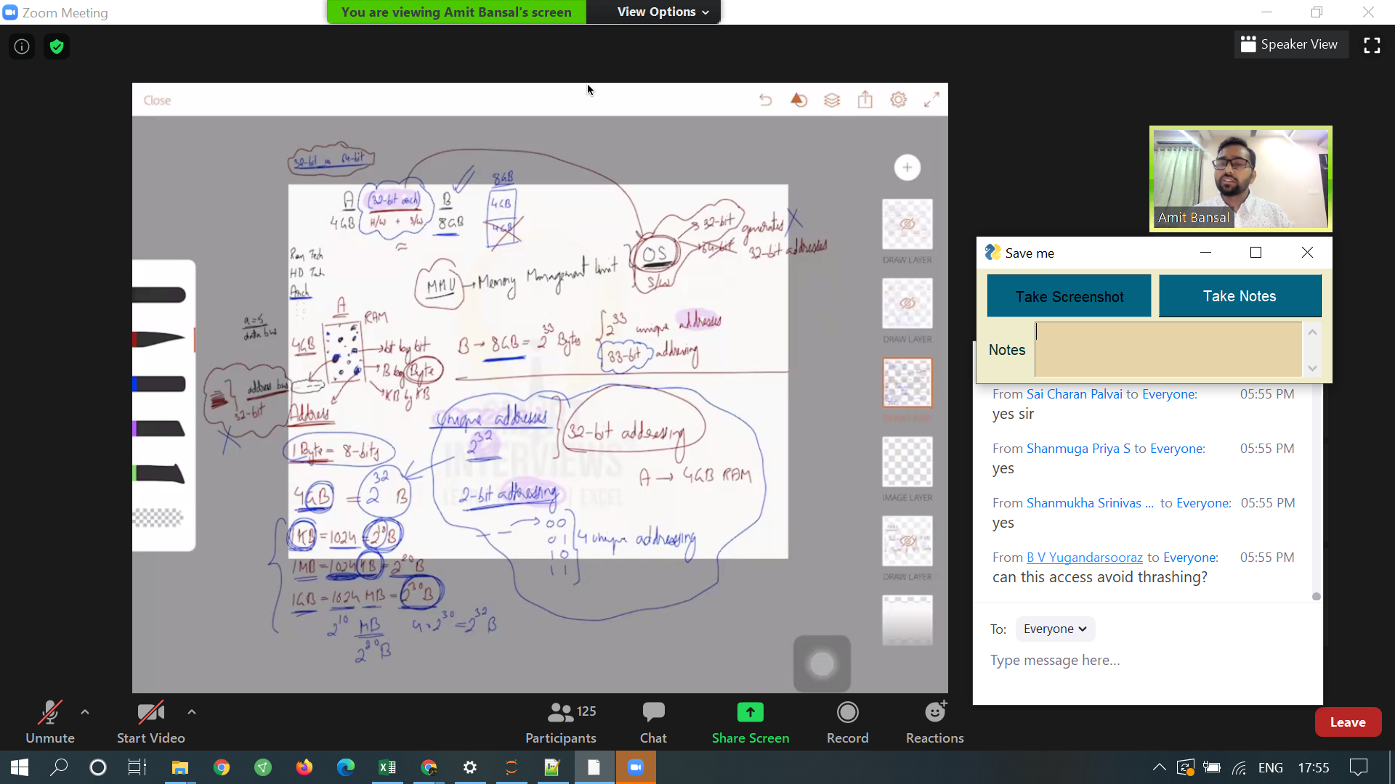

If your ram size are 4gb and 8gb, but your OS is 32bit and installed on 8gb, it is of no use, only 4gb is used and rest 4gb is not used.   
So both the systems have same performance.

#TODO-  
3. More differences of 32bit vs 64 bit.

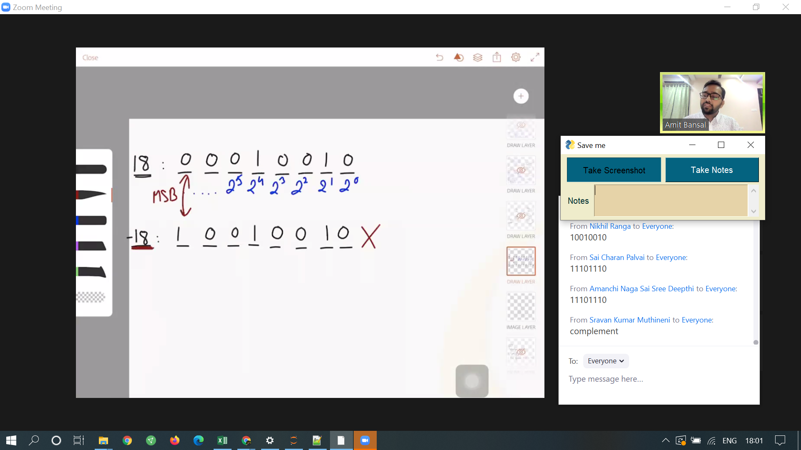

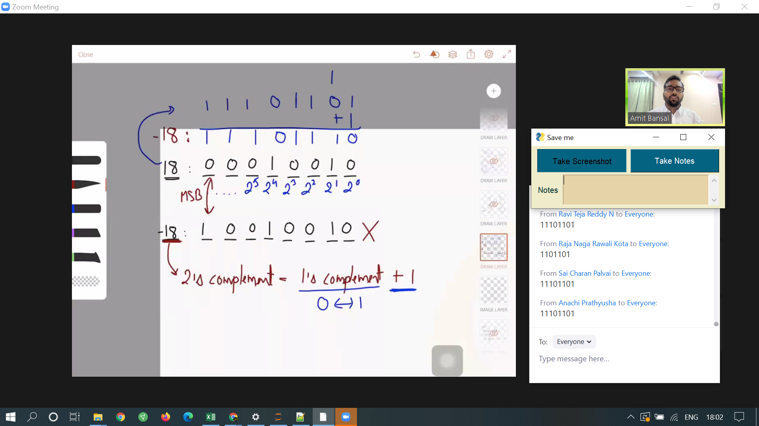

Binary form of -18.

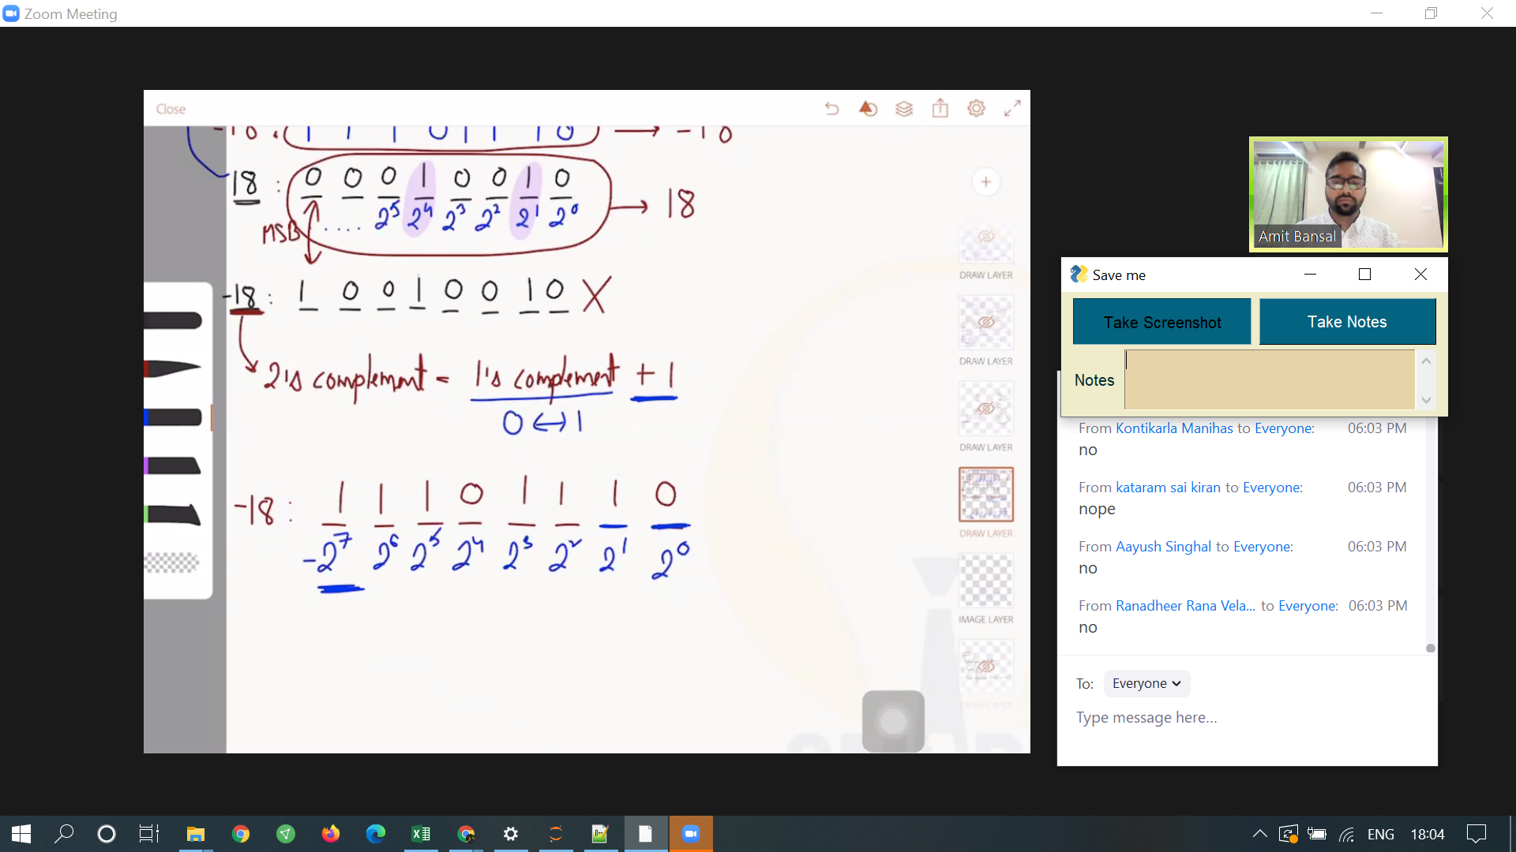

1st element is -2^7 when converting into decimal.  
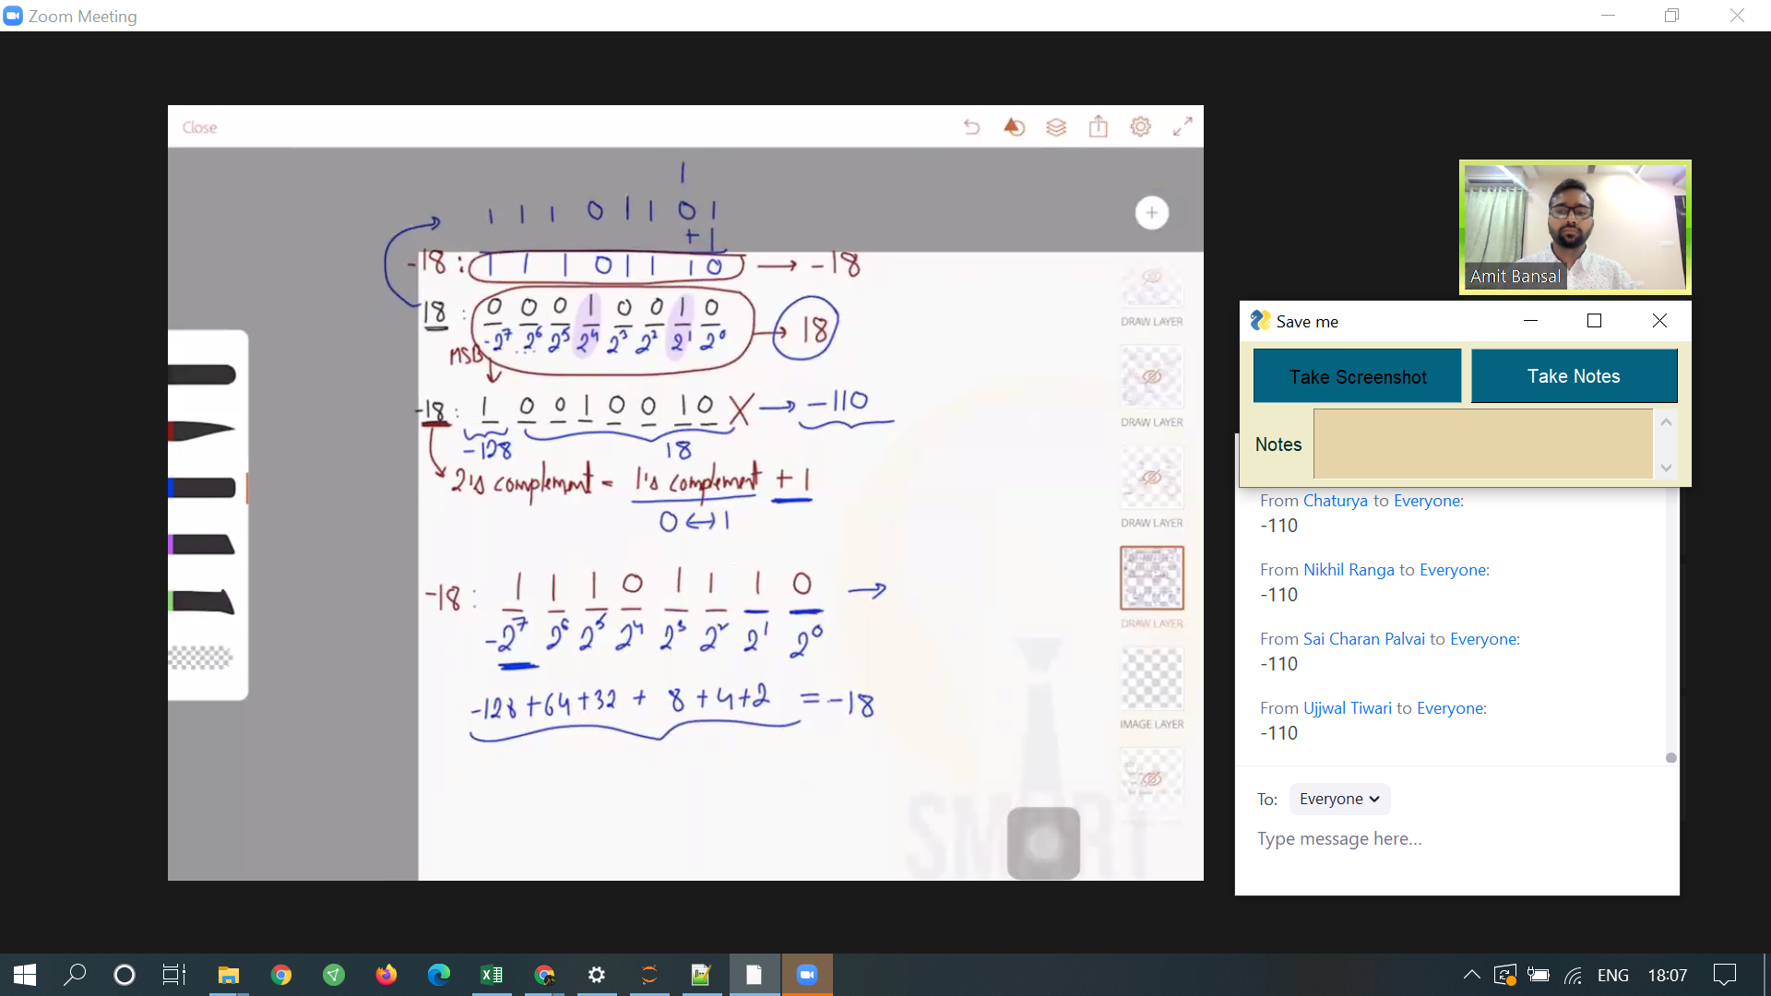

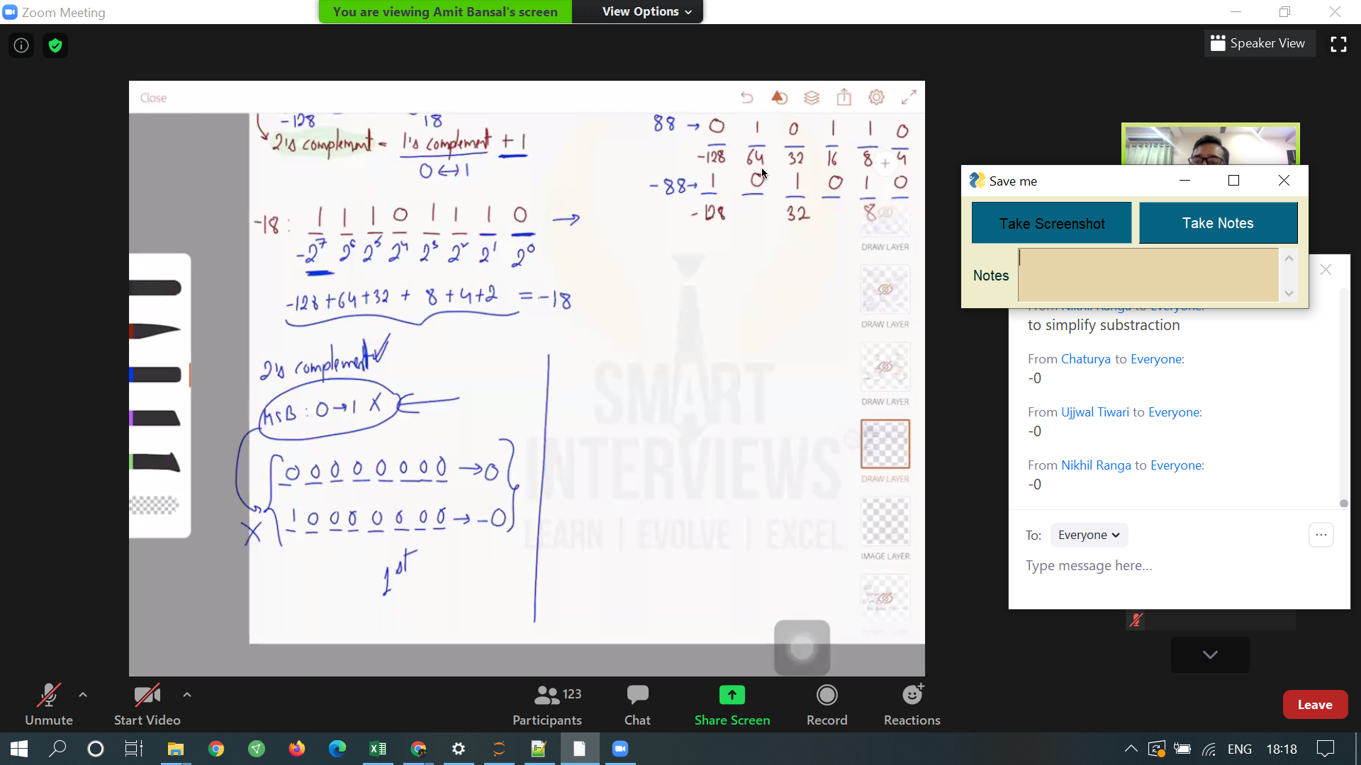

msb - 0 -->1 is not used.  
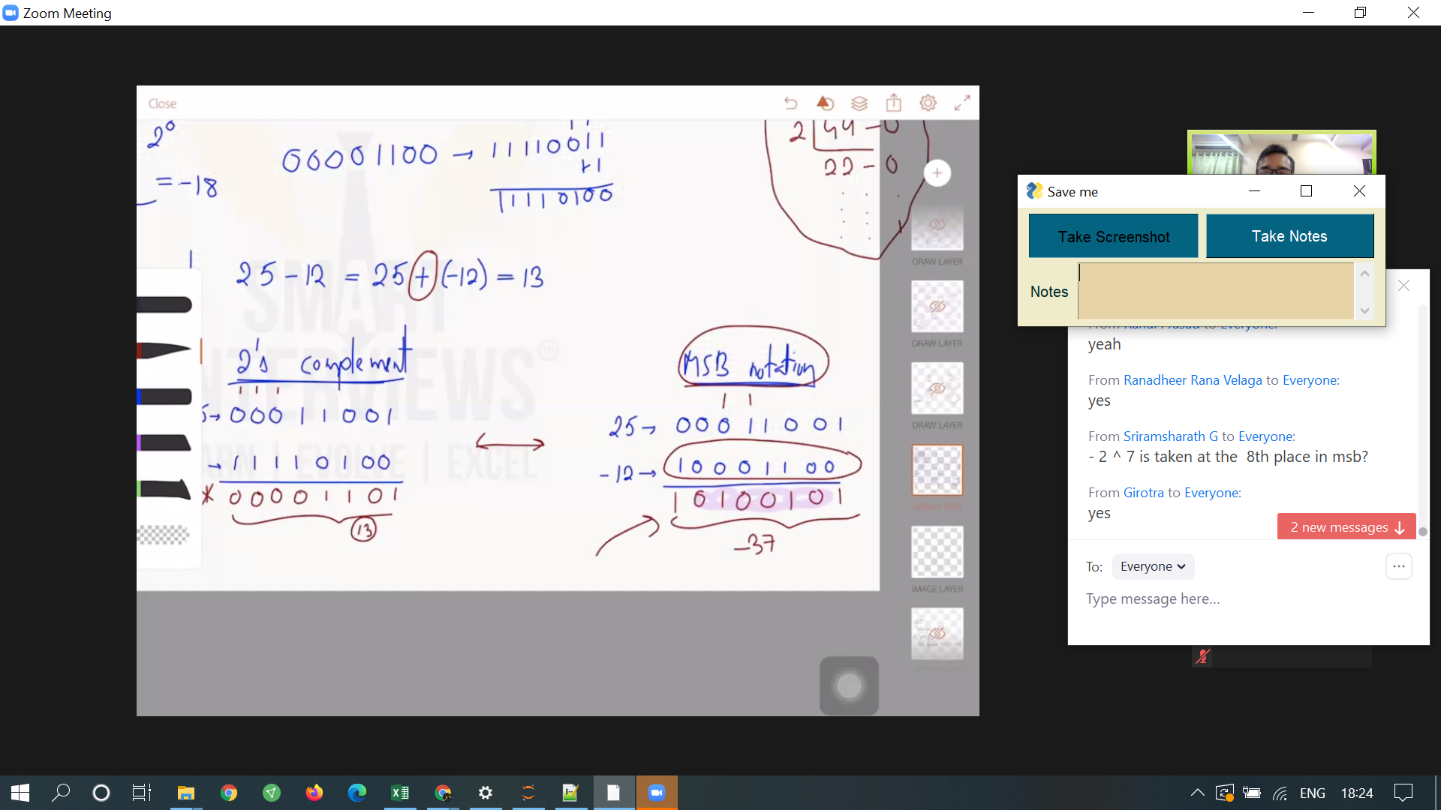

Difference between 2's compliment and MSB Notation.  
subtractions can be done as additions. it is correctly done in 2s compliment and not in MSB notation.

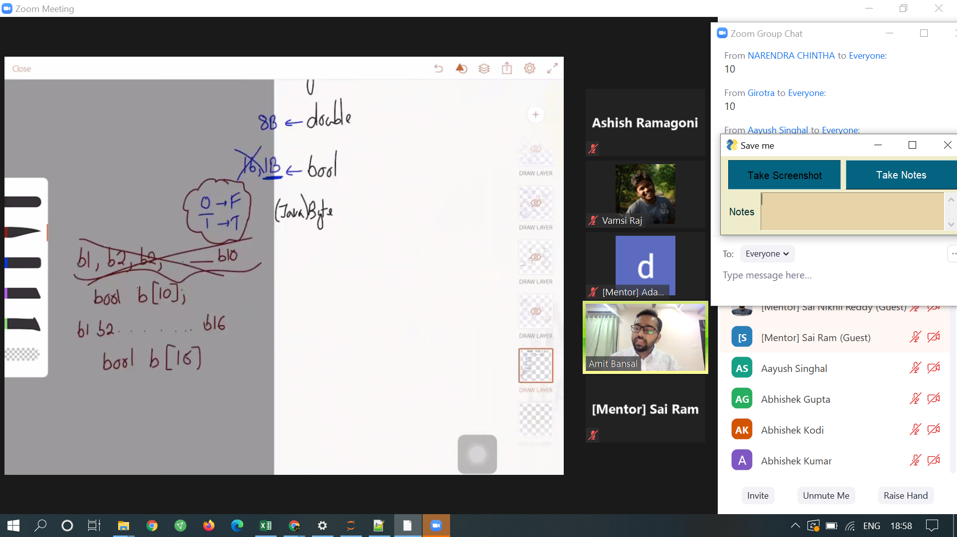

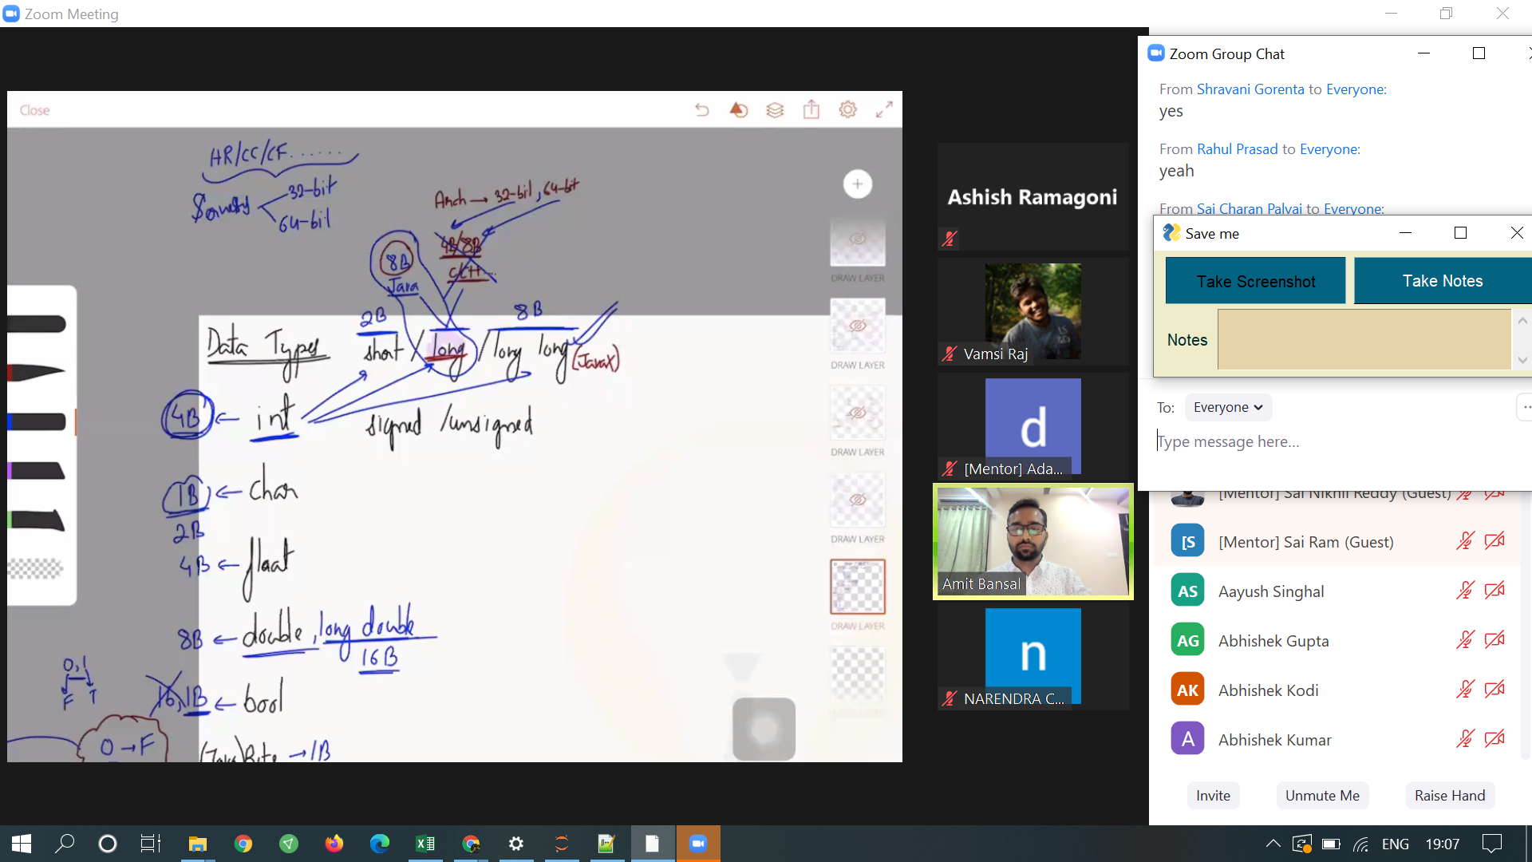

## Data types and their sizes

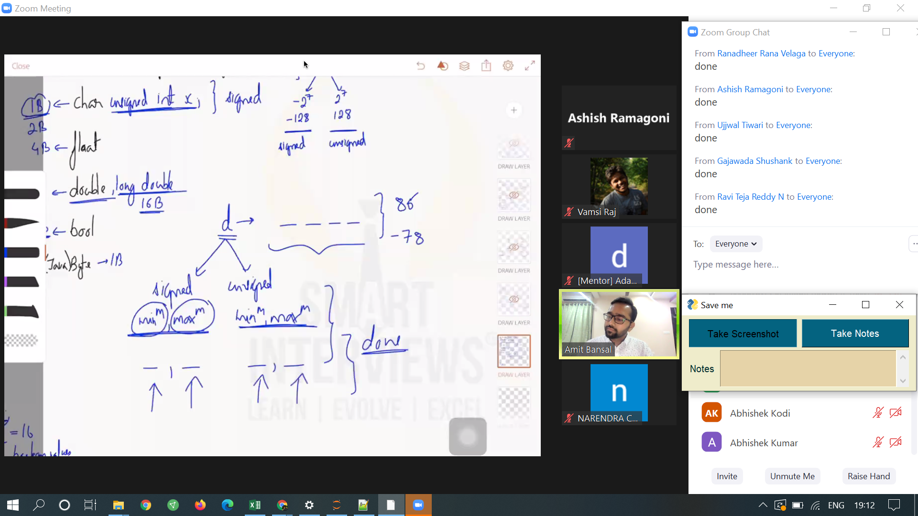

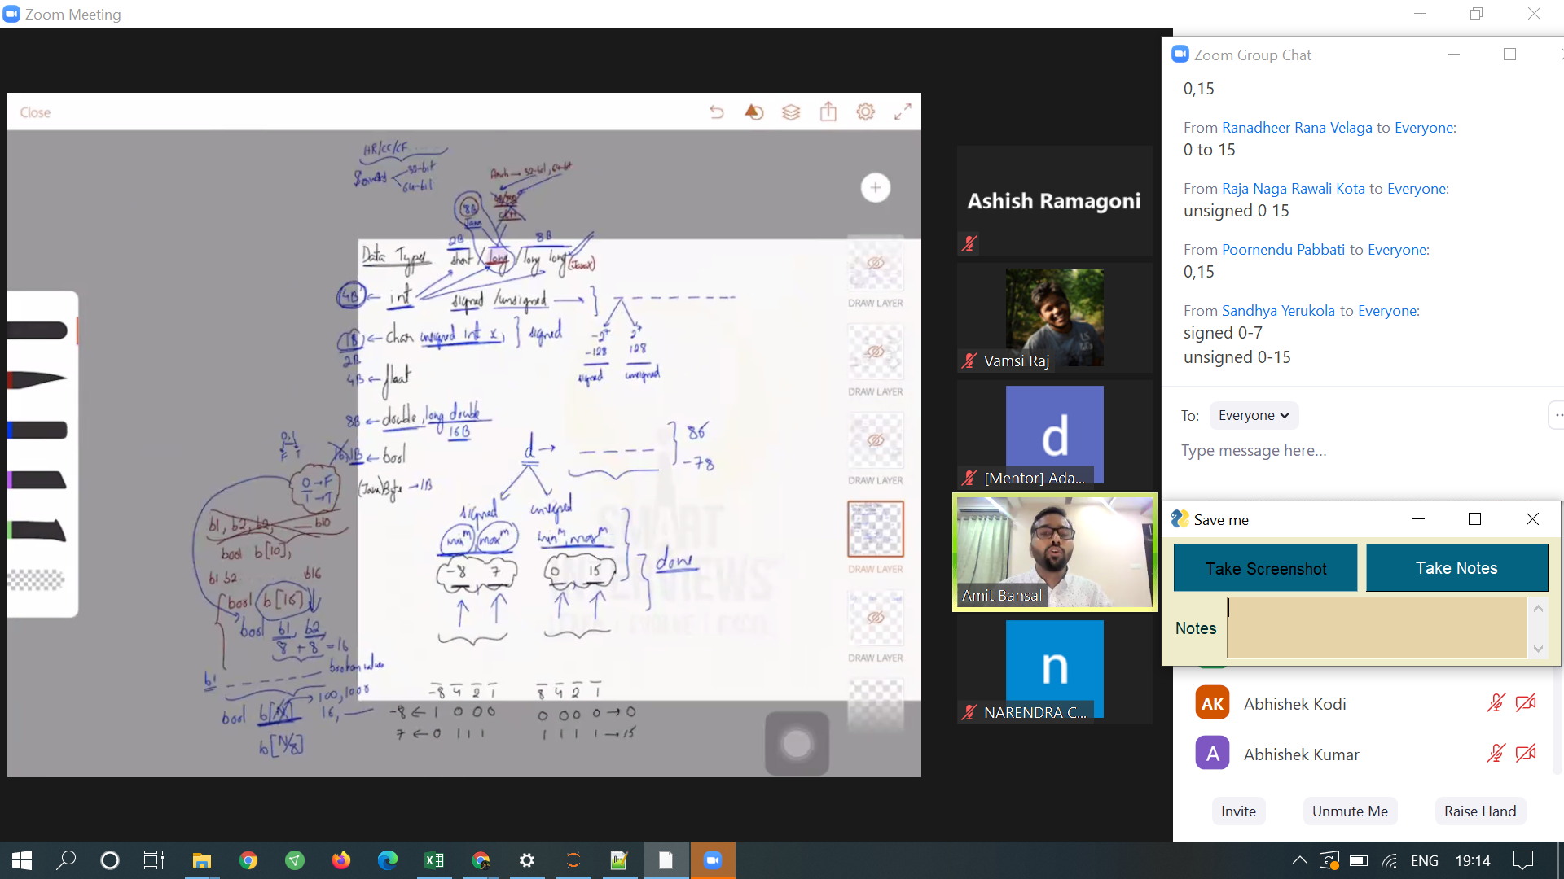

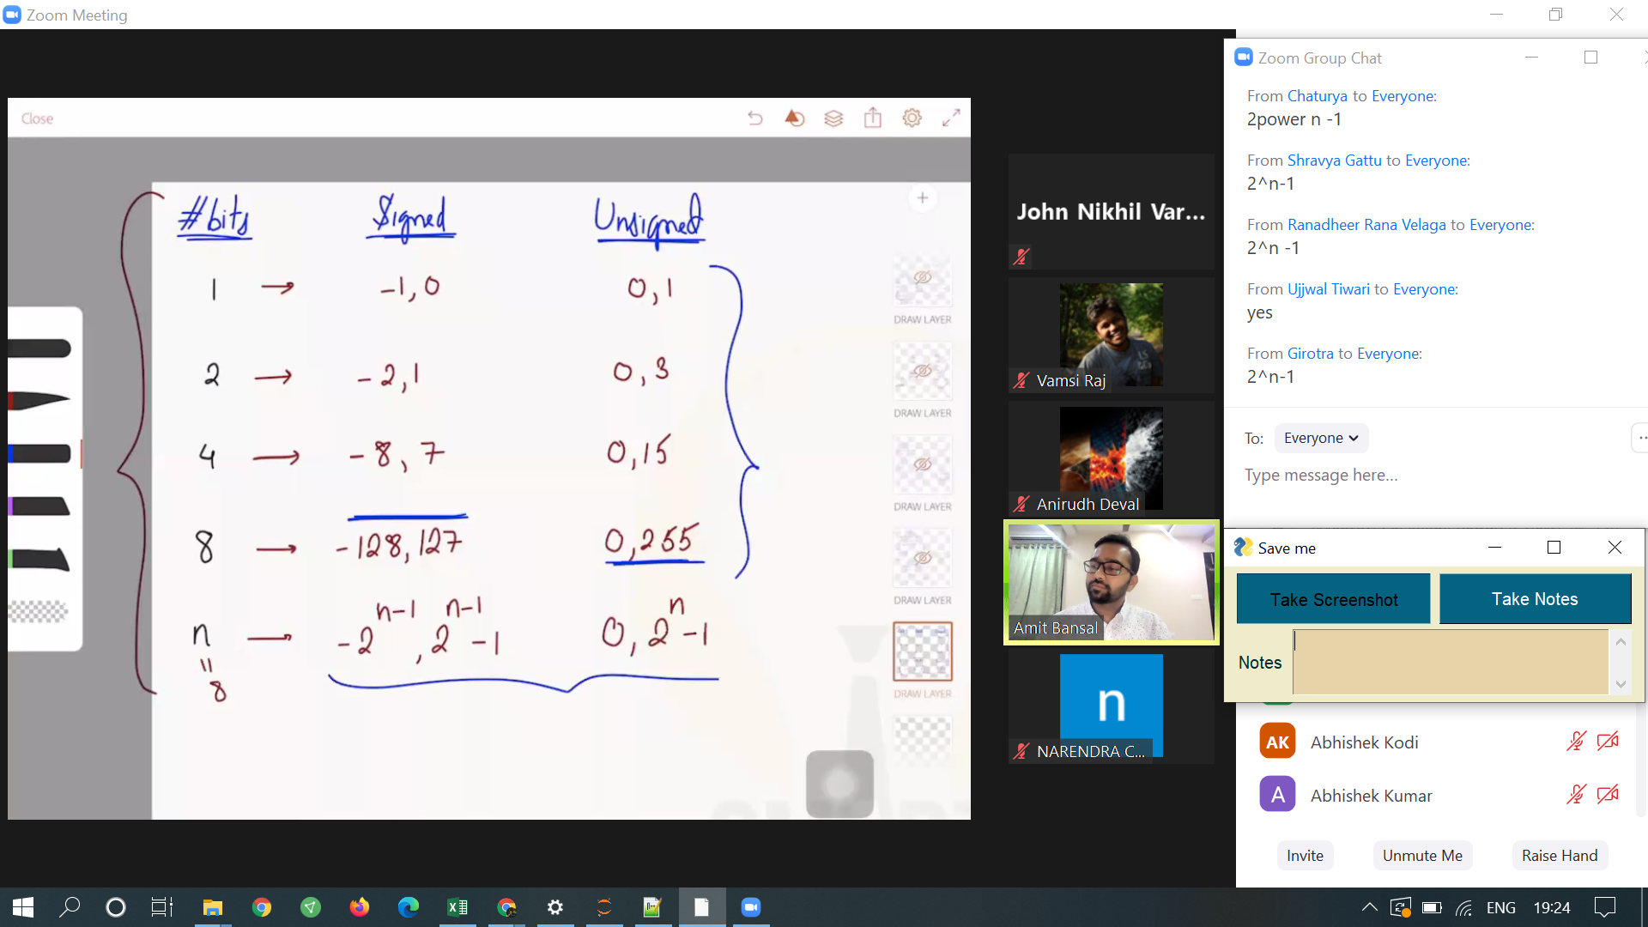

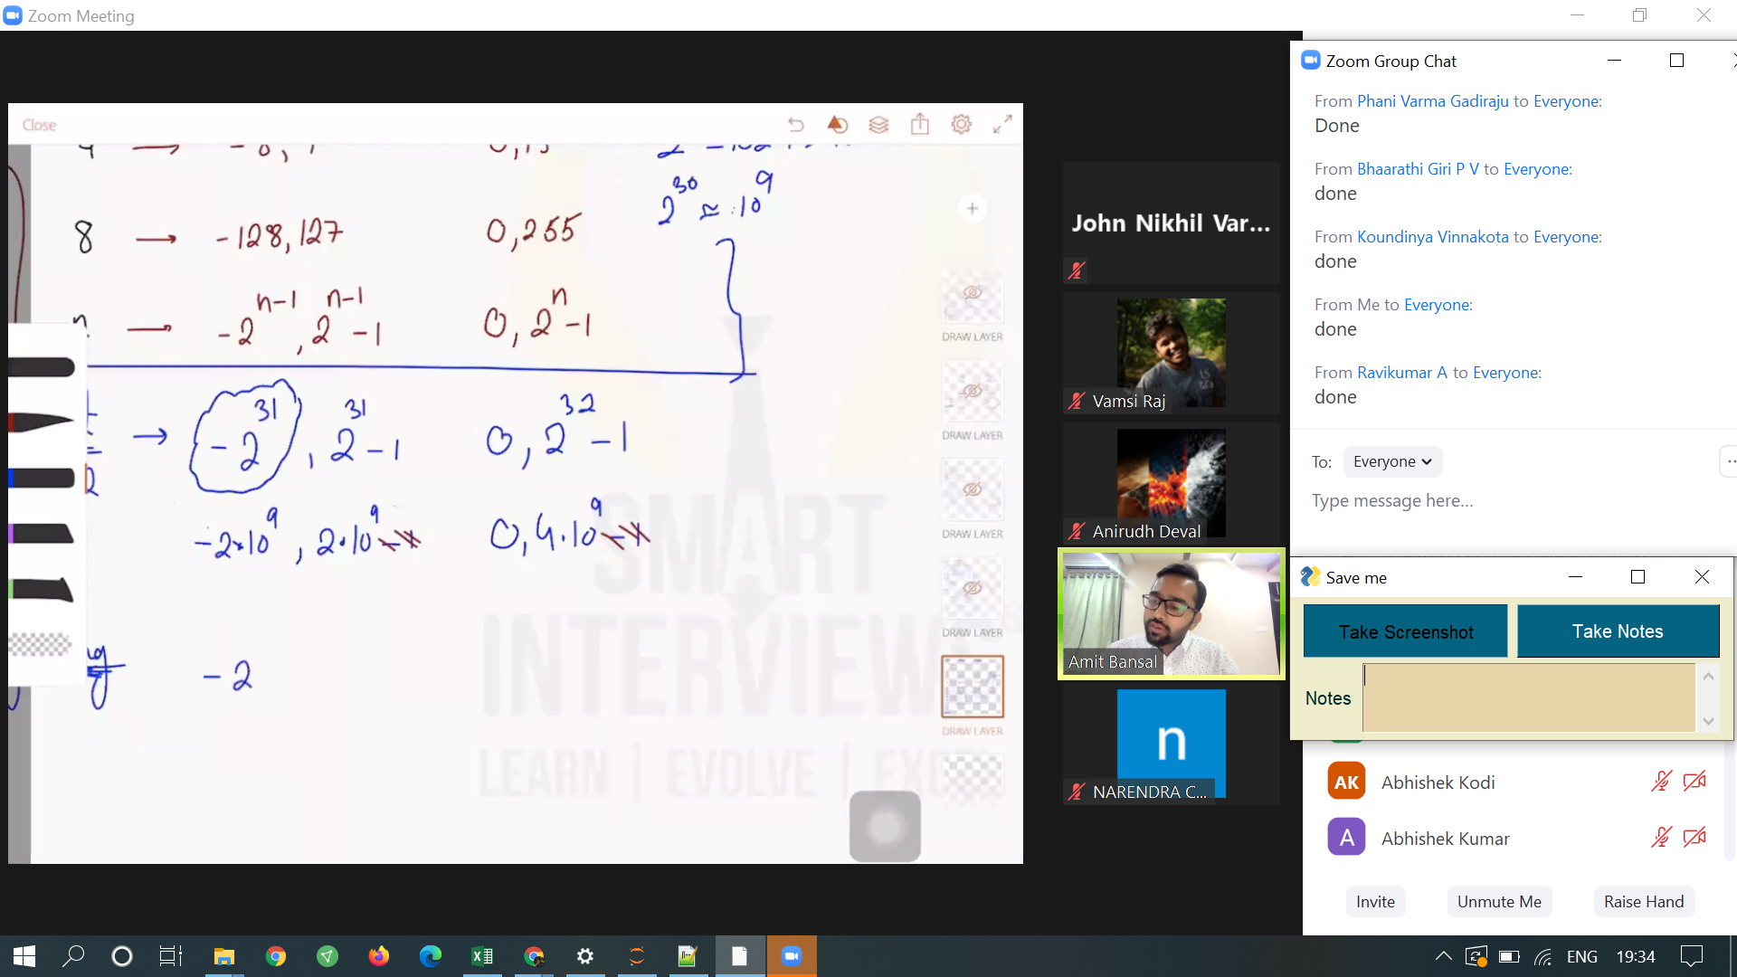

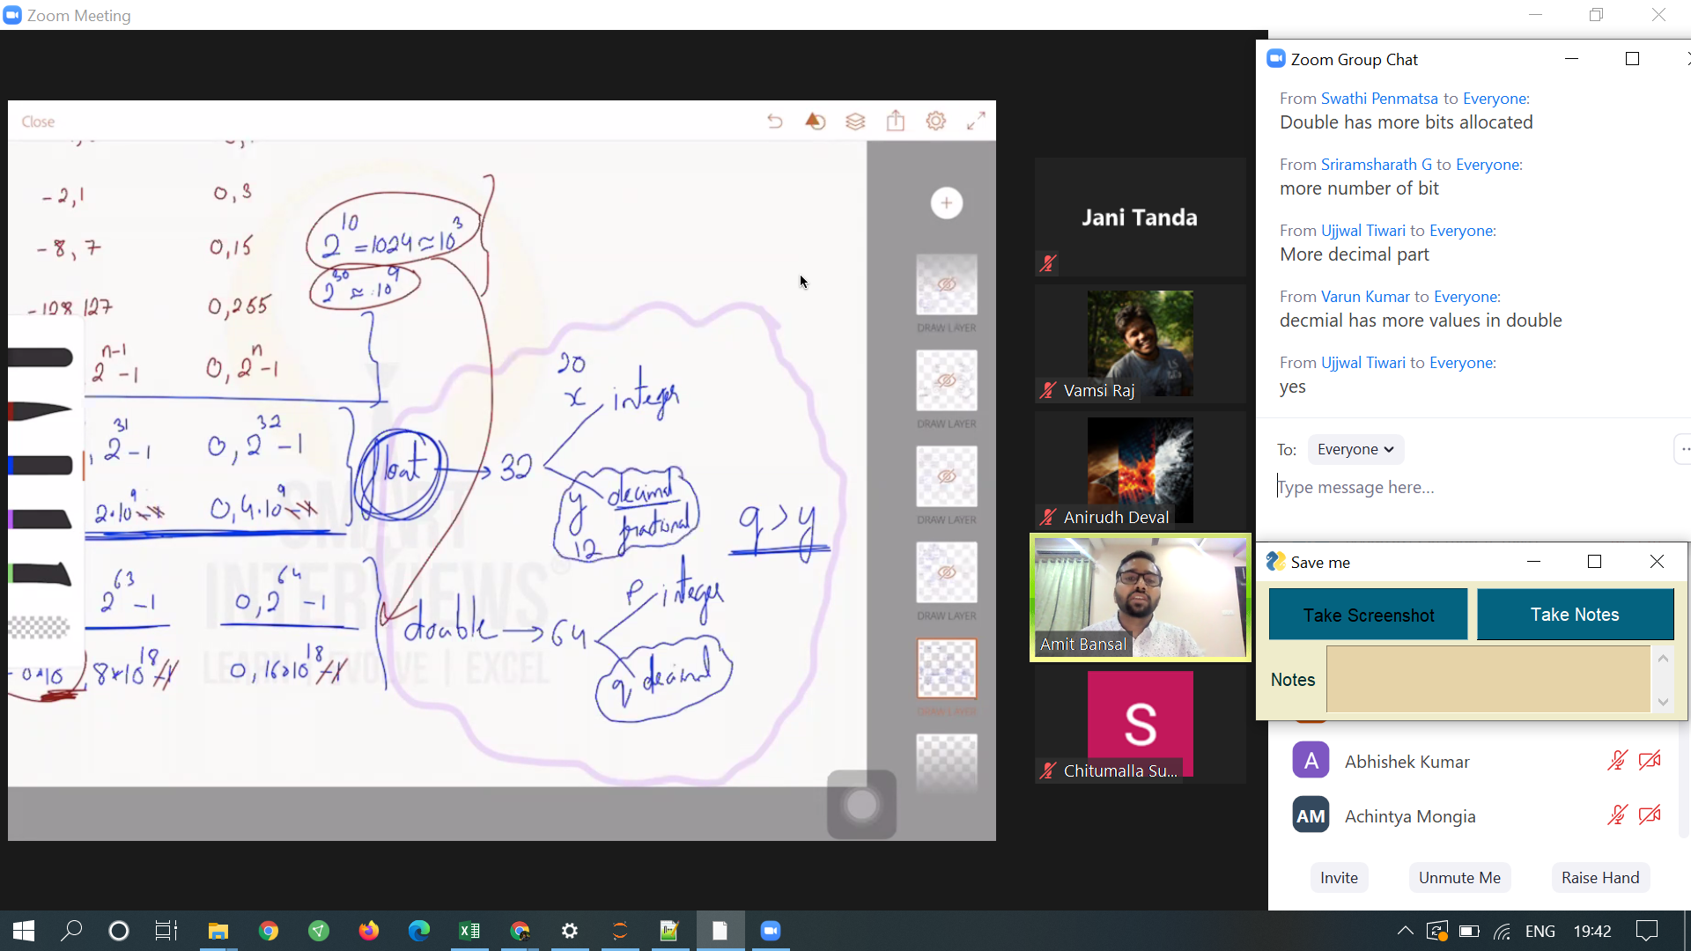

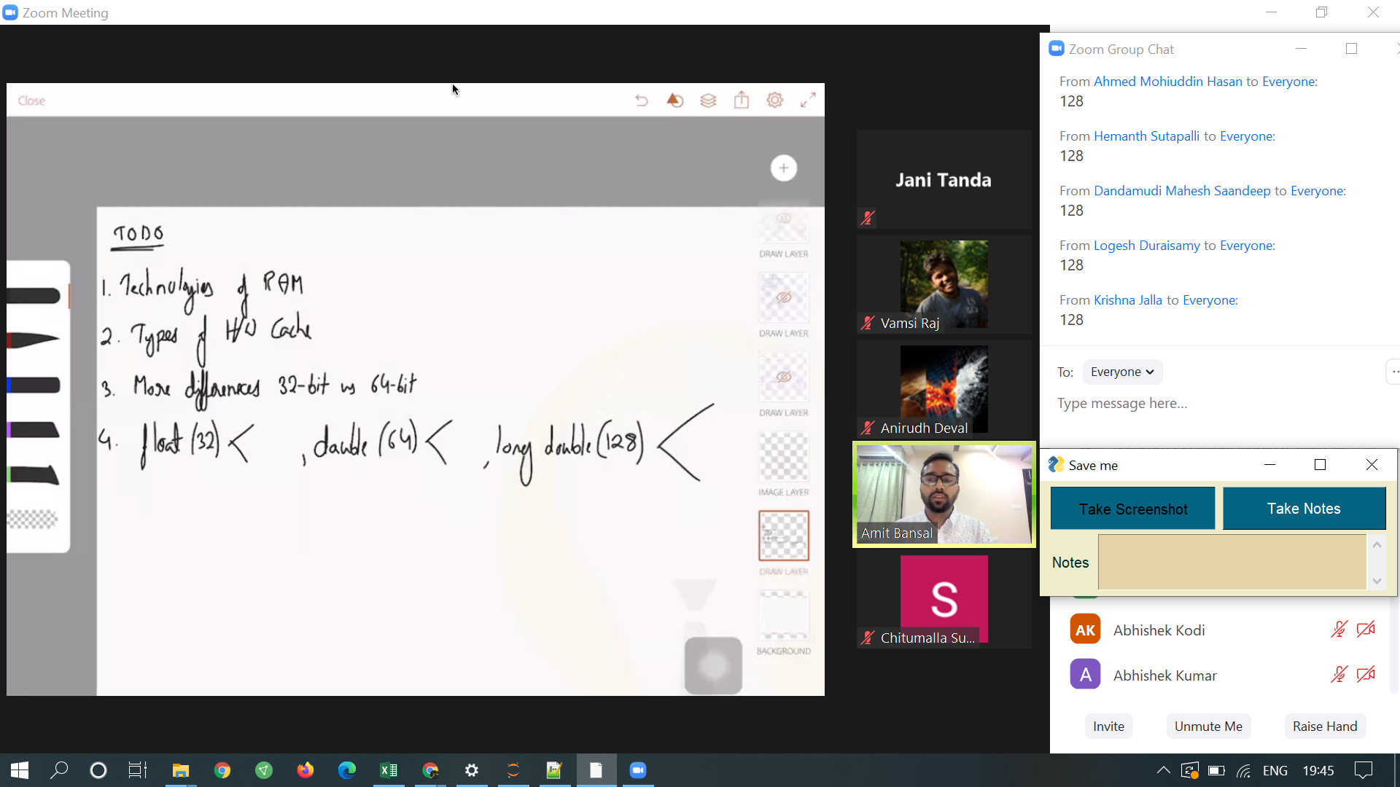

#TODO  
Bit distribution for float, double

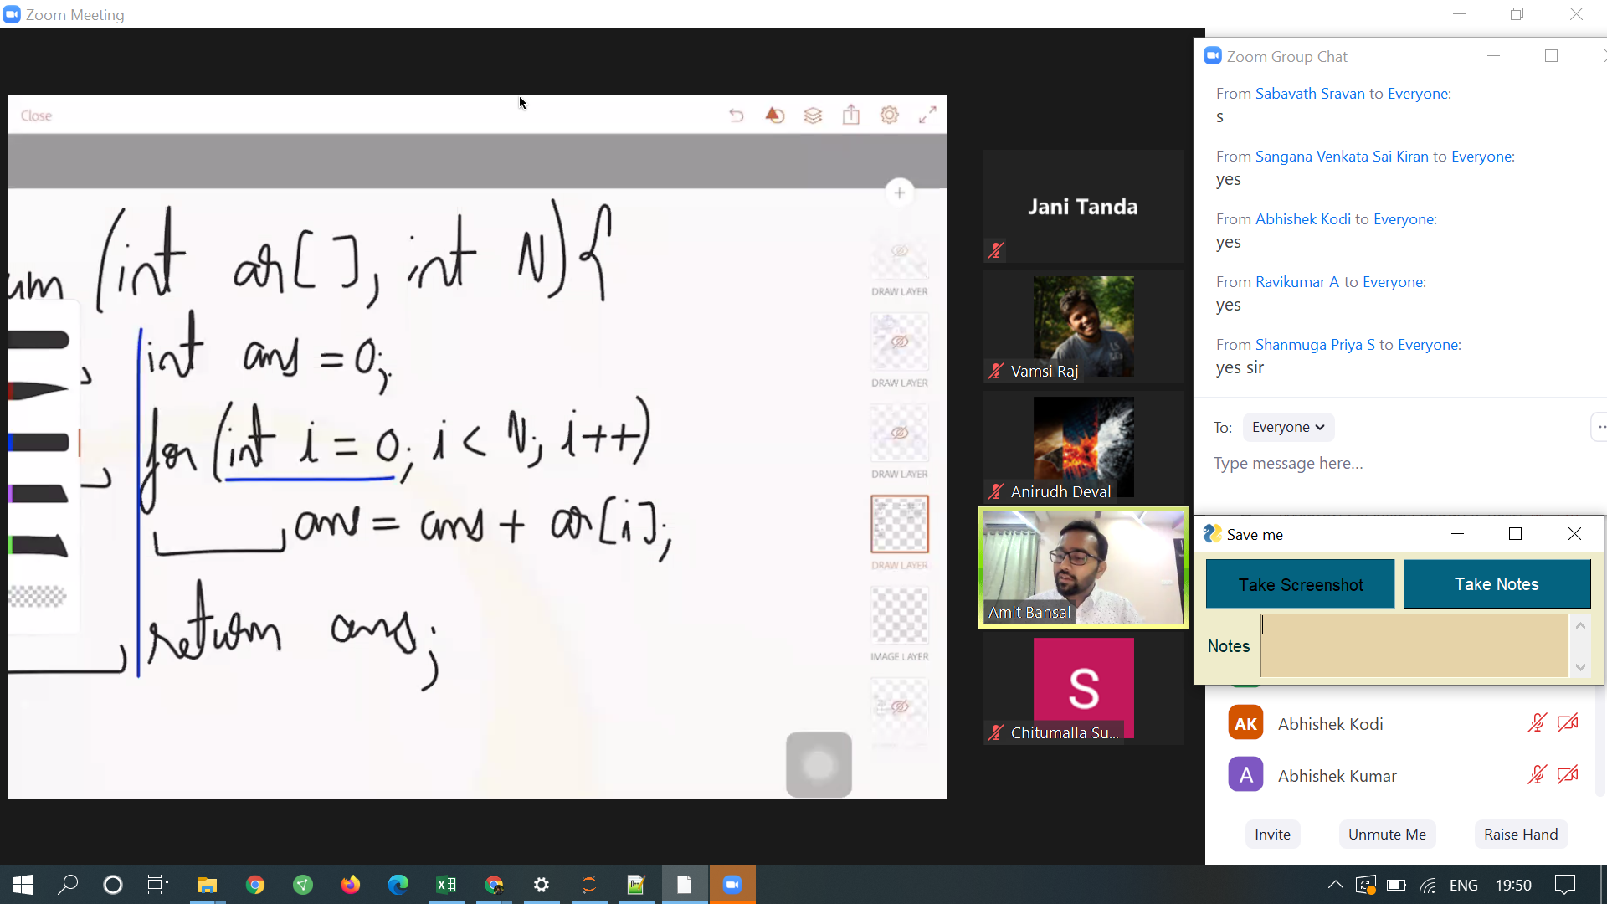

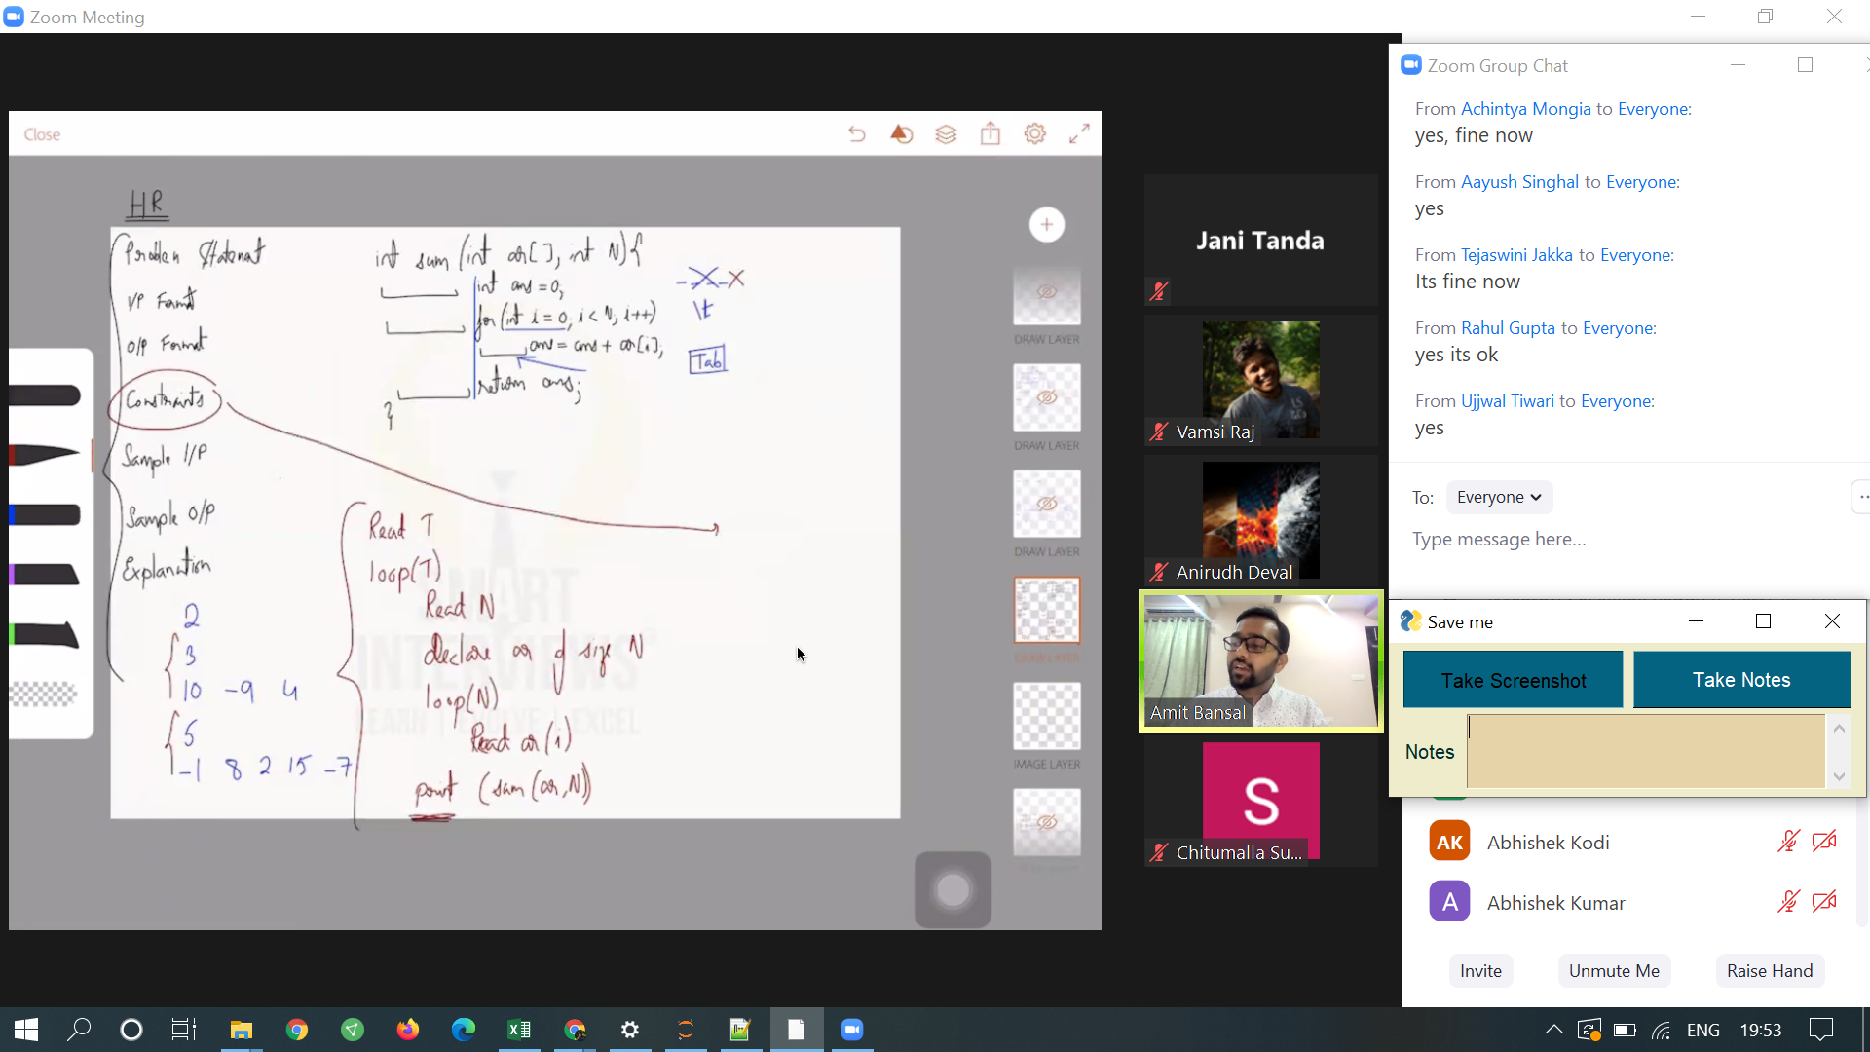

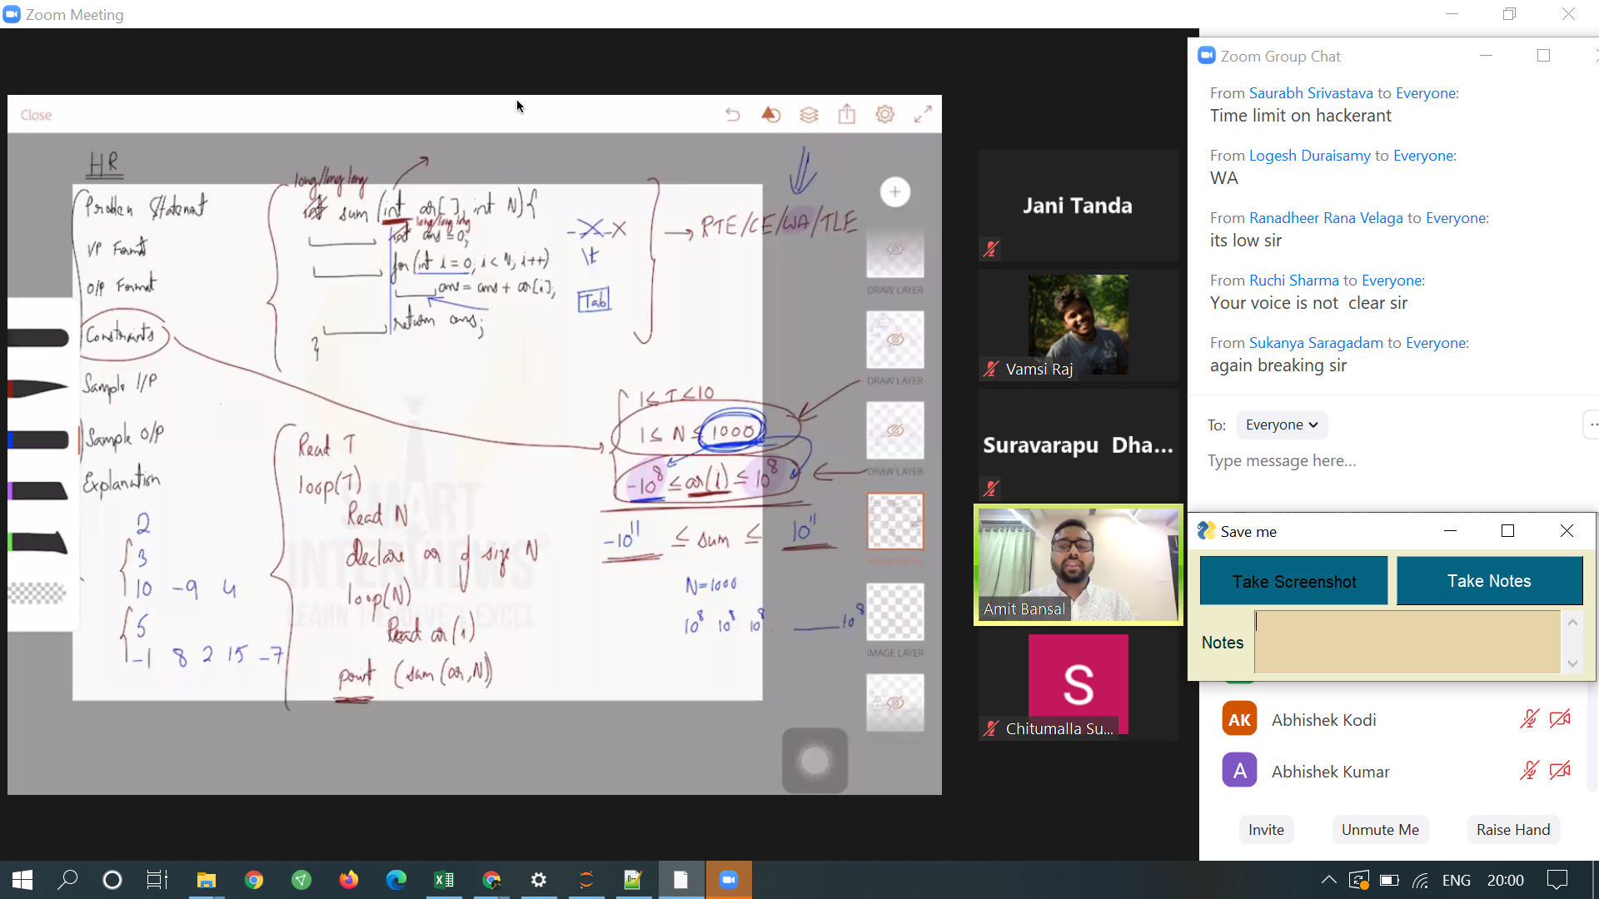

#TODO  
Sum of elements in array problem should be solved.

https://www.hackerrank.com/contests/smart-interviews/challenges/si-sum-of-array-elements